Website of fake data base: https://www.w3schools.com/sql/trysql.asp?filename=trysql_asc
First Query: SELECT * FROM Products WHERE ProductID = 2 AND Price = 19;
picture of result of First query:
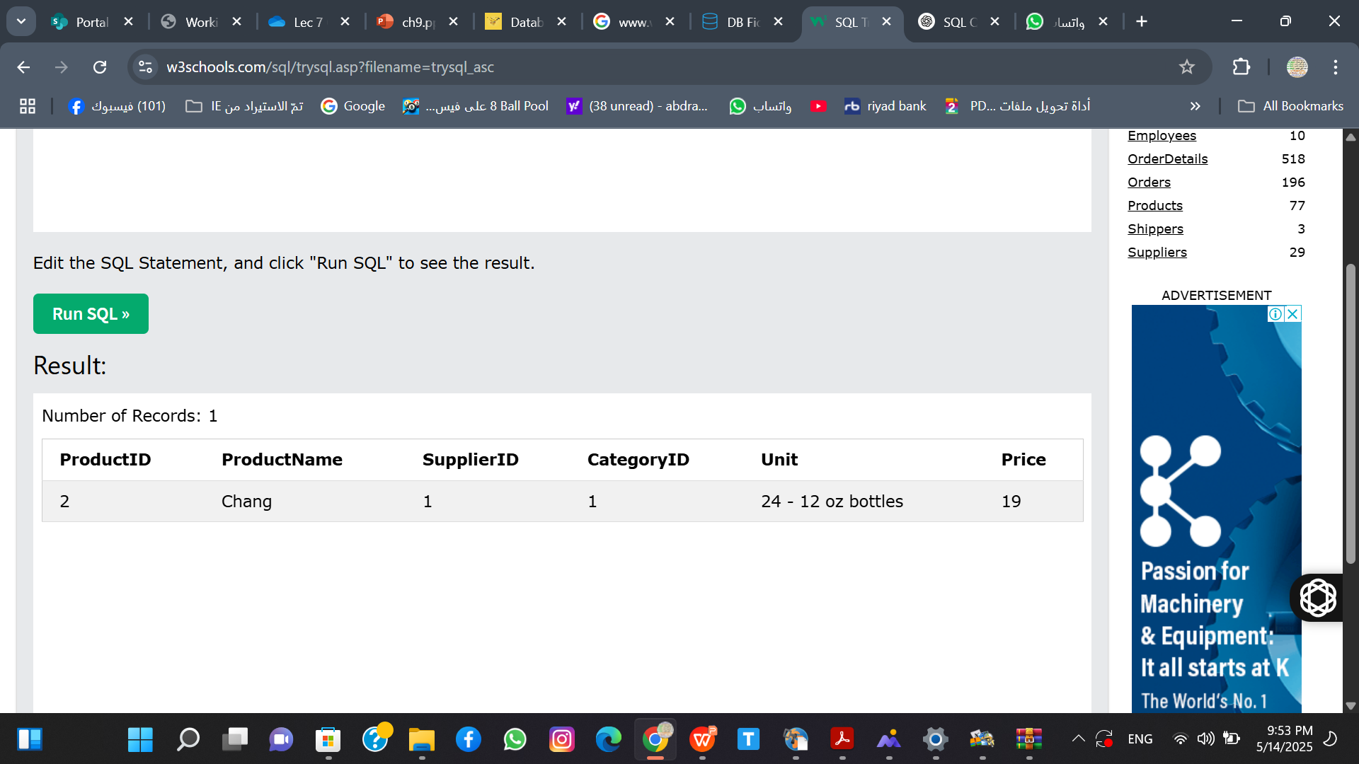

Second query and result from it.


Third query and result from it:
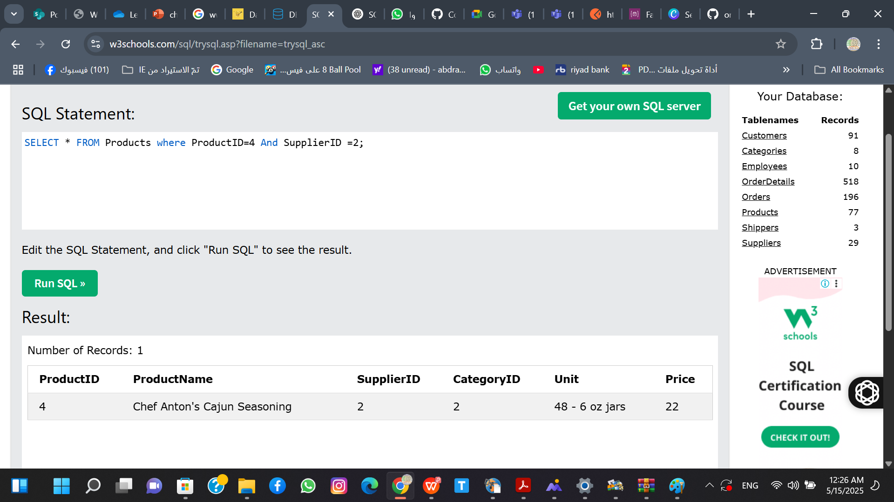

Forth Query and the result from it:
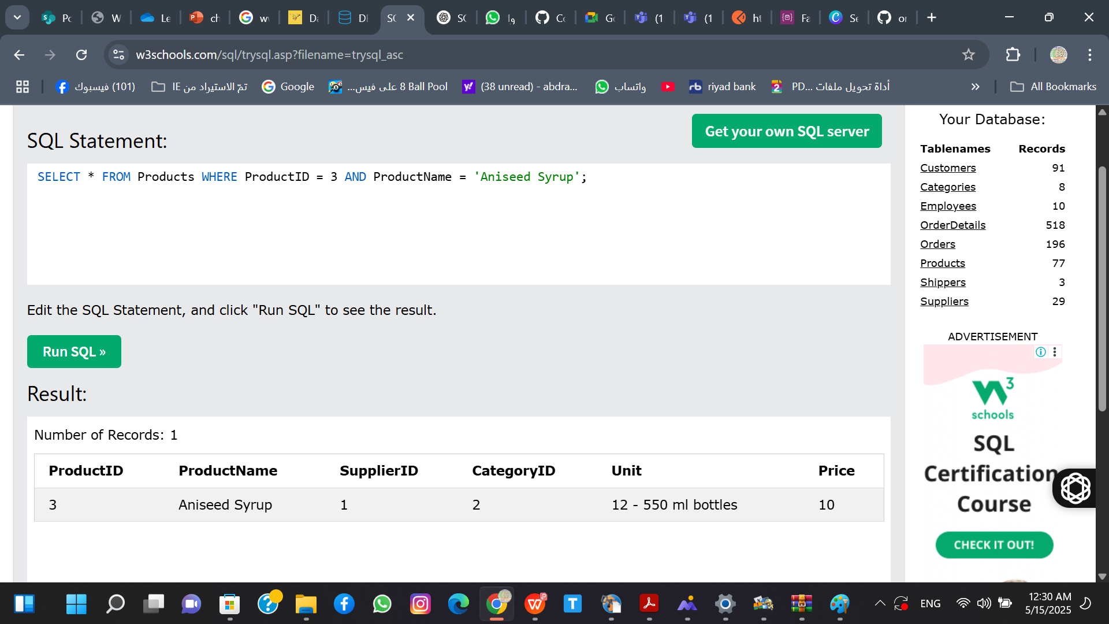

Anothor fake data base from dp fiddle

Schema SQL
-- Create the table
CREATE TABLE users (
Id INT PRIMARY KEY,
`Full Name` VARCHAR(100),
Country VARCHAR(100),
`Created At` DATETIME,
Email VARCHAR(100)
);

-- Insert data
INSERT INTO users (Id, `Full Name`, Country, `Created At`, Email) VALUES
(0, 'Kris Cartwright', 'Chile', '1998-06-30 00:06:40', 'Robin_Quitzon@brown.tv'),
(1, 'Jordan Bradtke', 'British Antarctic Territory', '2017-02-18 13:35:18', 'Margret.Vandervort@bridgette.us'),
(2, 'Evelyn Pouros', 'Falkland Islands', '1994-07-04 08:10:37', 'London_Stehr@gillian.info'),
(3, 'Marques Morar', 'Andorra', '2000-07-05 20:02:33', 'Tierra.Romaguera@oral.io');

Queries:
SELECT * FROM users WHERE Id = 0;
SELECT * FROM users WHERE Id = 1;
SELECT * FROM users WHERE Id = 2;
Results:
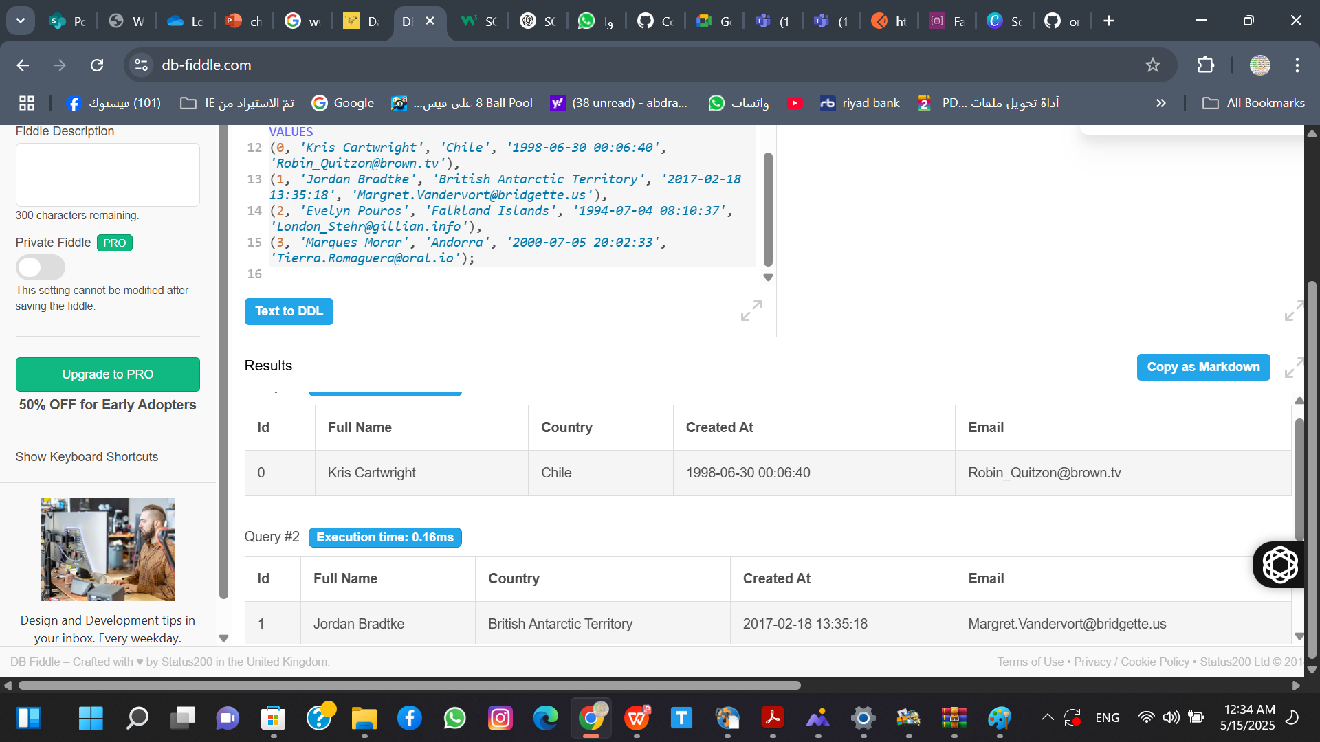
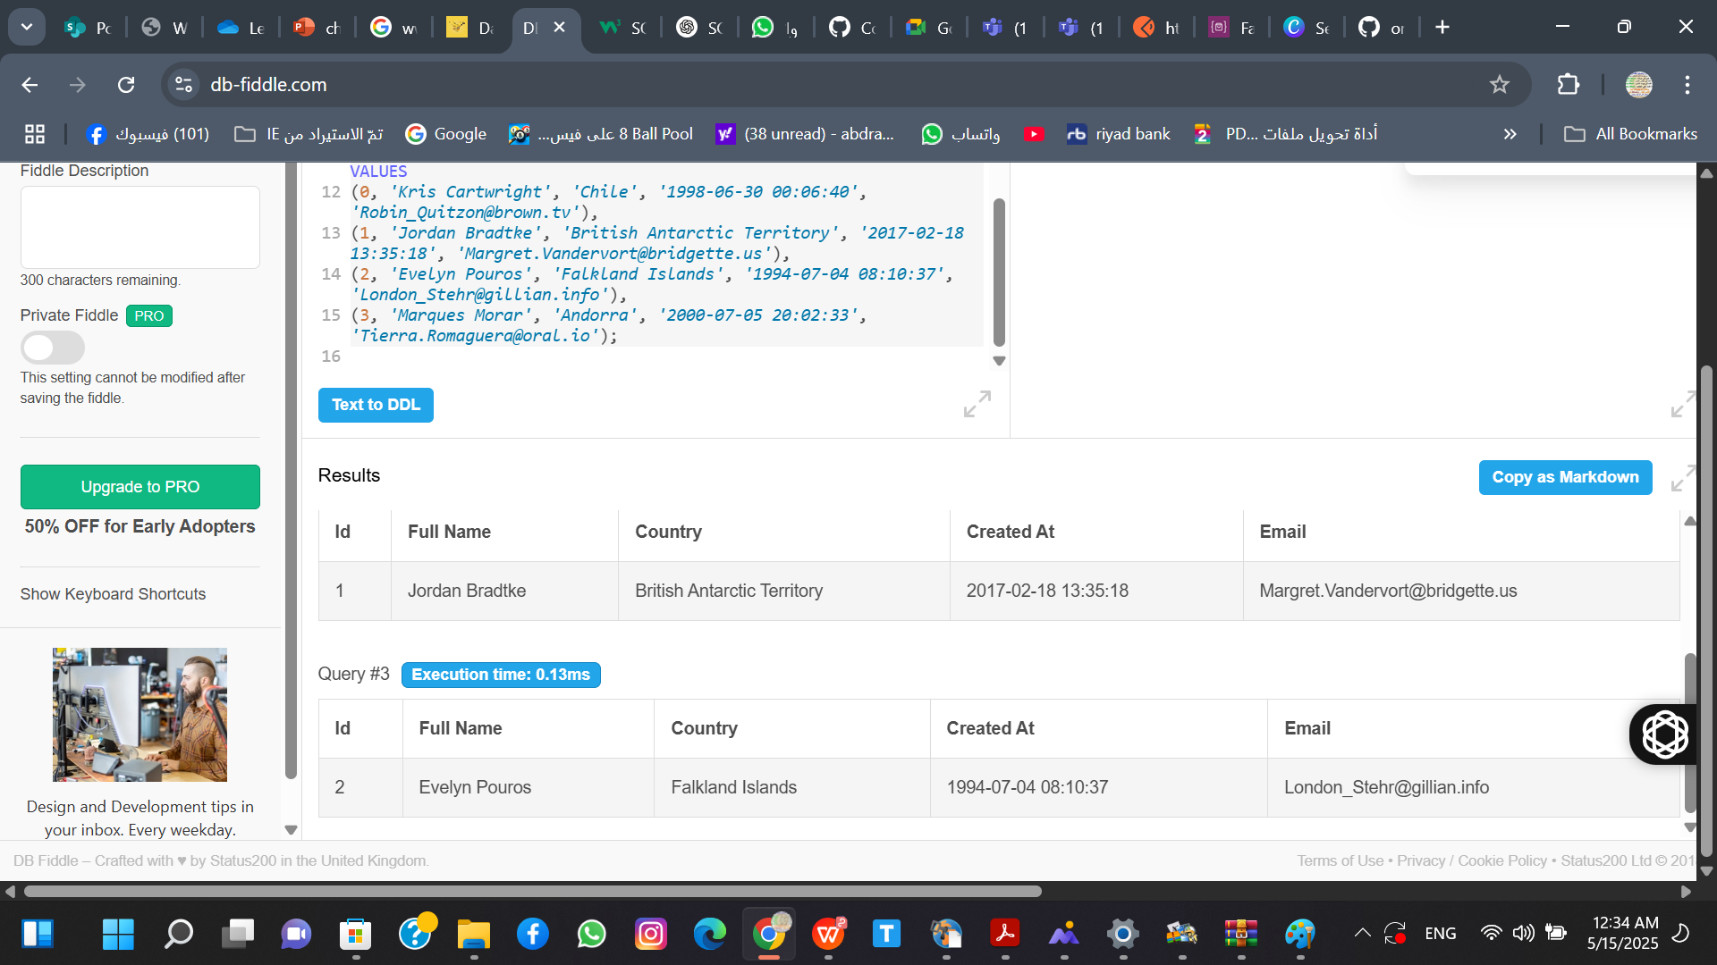

END

